We got a peek inside a $20 million apartment in the latest skyscraper to dramatically alter Manhattan's skyline

Sarah Jacobs

Mar. 27, 2017

Property developer Bruce Eichner stands in the study of the 56th-floor apartment. Sarah Jacobs Madison Square Park Tower is changing Manhattan's skyline. The 65-story glass skyscraper is the tallest in its Flatiron District neighborhood, and because of various zoning laws surrounding it, its fantastic views will never be obstructed. While the building won't be fully completed until 2018, 70% of the units have already sold, according to property developer Bruce Eichner.
Business Insider recently visited the 56th-floor apartment, which boasts a price tag of $20 million and 360-degree views of the city. Ahead, get the full tour.

The tower sits at 45 East 22nd Street, at the base of New York's iconic Madison Square Park. While it is still unfinished, residents can begin moving in later this fall. The building's amenities will include a fitness center, golf simulator, basketball court, children's playroom, library, billiards, cards room, and a terrace with an outdoor grill.

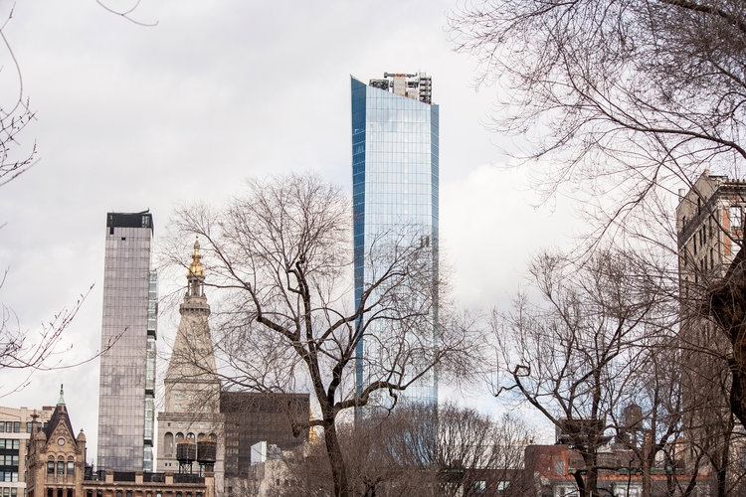Photo courtesy of Madison Square Park Tower

The 56th-floor apartment we viewed has gorgeous views of the entire city and totals 4,655 square feet of space.
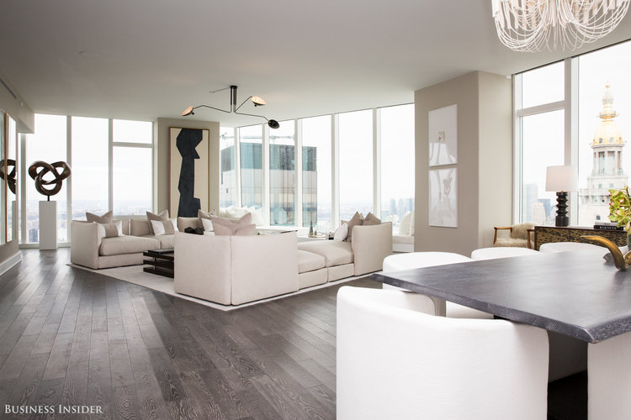
Sarah Jacobs

The living room looks out on the Met Life Tower, and just behind that is the Empire State Building.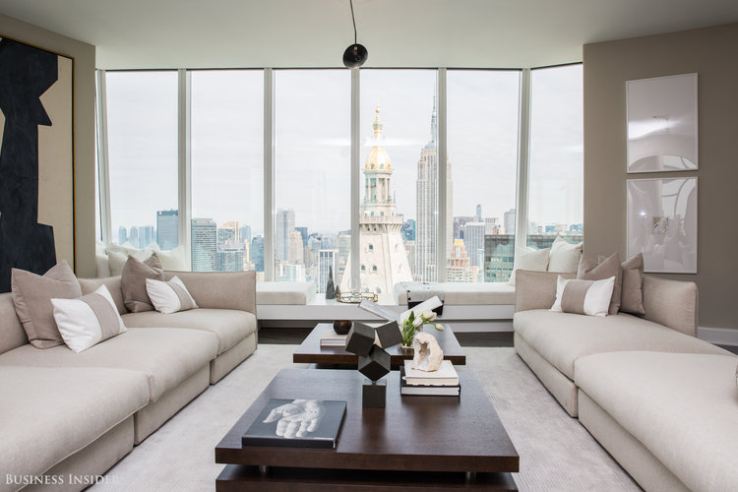

Sarah Jacobs

It also has a view of Rupert Murdoch's penthouse at One Madison, which he purchased for $57.25 million in 2014.
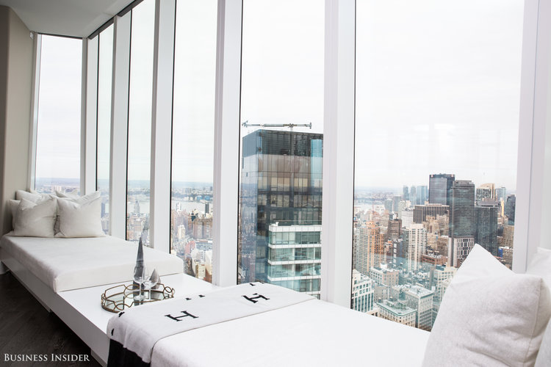Sarah Jacobs
Source: Curbed

Residents can accommodate large dinner parties in their homes, but if that's not big enough, they can also utilize one of the building's two entertaining spaces.
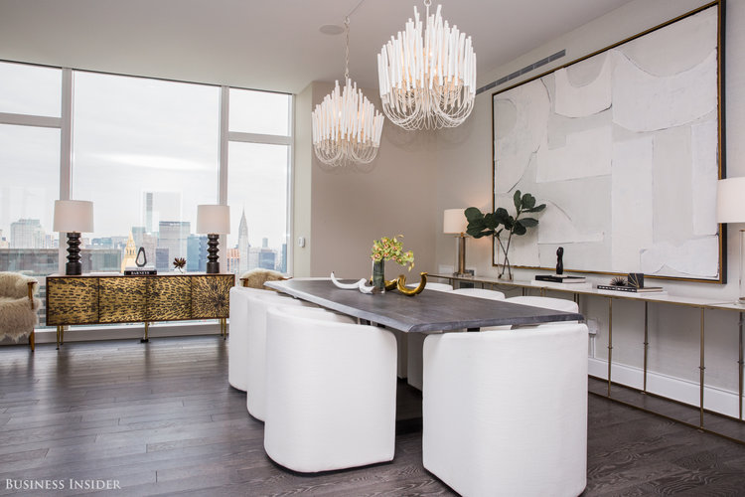Sarah Jacobs
The apartment's study looks out onto Lower Manhattan.
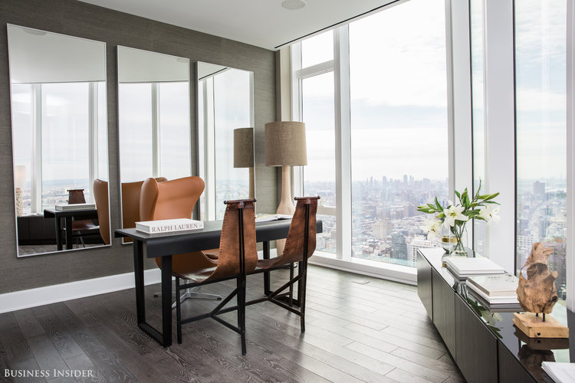Sarah Jacobs

The kitchen has a marble countertop and backsplash, and above the island hangs a glass gantry for decorative storage.
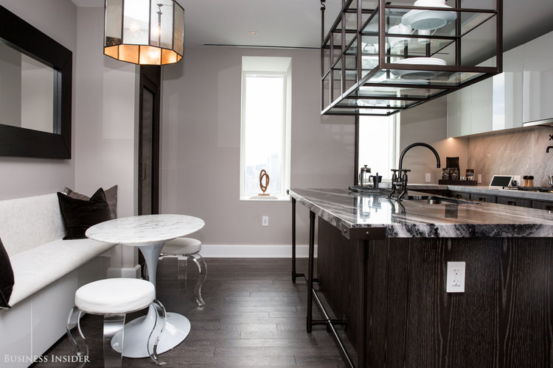Sarah Jacobs
Ceiling heights are between 10 and 10.5 feet in living rooms and in master bedrooms like this one.
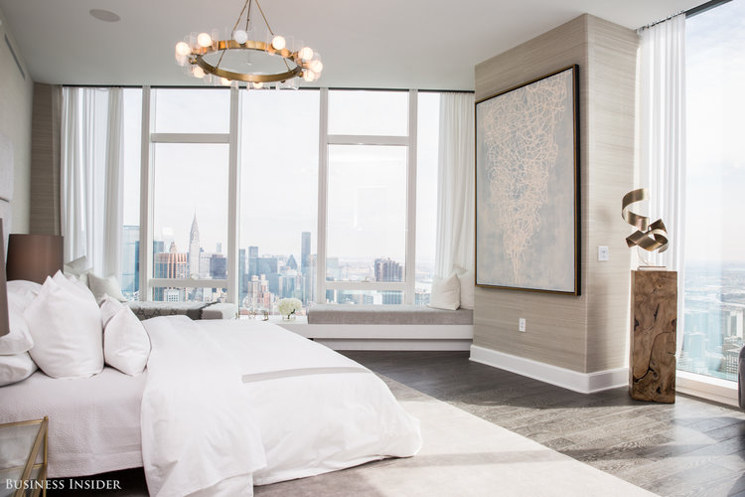Sarah Jacobs

Solid Appalachian white oak flooring covers most of the apartment.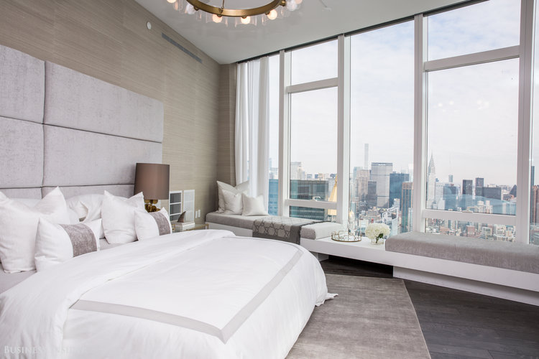Sarah Jacobs

There are two large walk-in closets adjacent to the master bedroom.
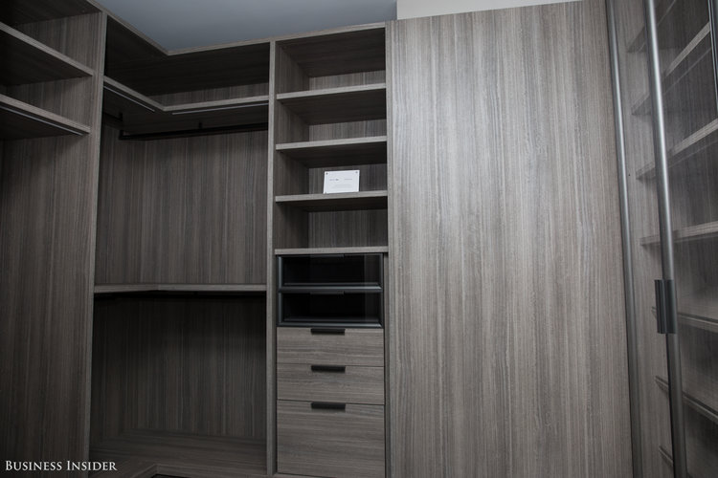Sarah Jacobs

The master bath sits just down the hall from the master bedroom.
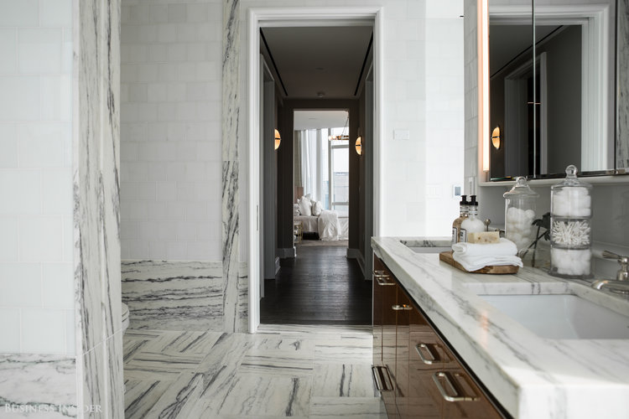Sarah Jacobs
White marble covers the countertop and the floor.
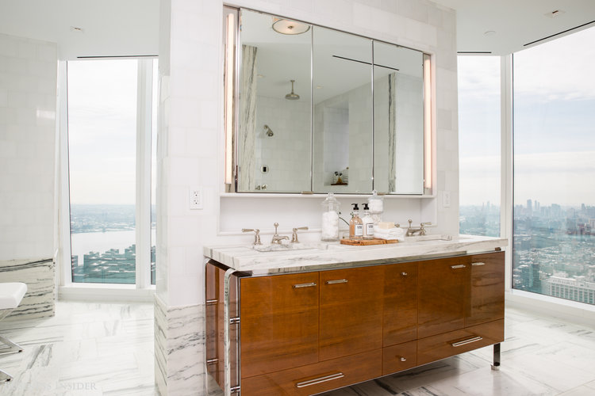
Sarah Jacobs

The bath tub has a fantastic view of the East River and One World Trade Center.
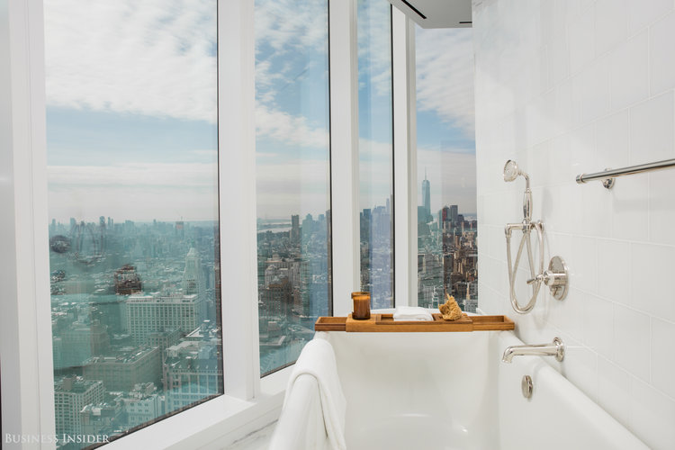Sarah Jacobs

But if you'd rather shower, there's a large rain shower head on the other side. Glass will be added to this one before people move in.

The secondary bathrooms are almost just as nice.
Sarah Jacobs

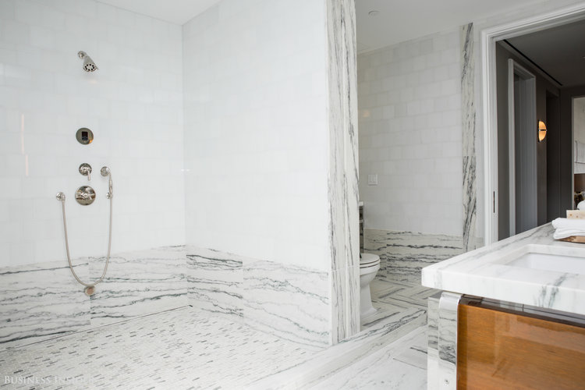
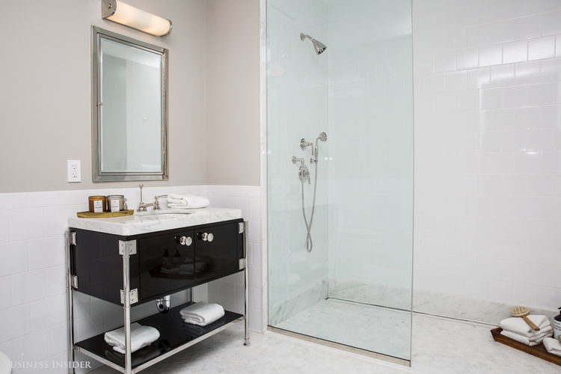Sarah Jacobs

LG washers and dryers can be found in the laundry room, located near the kitchen.
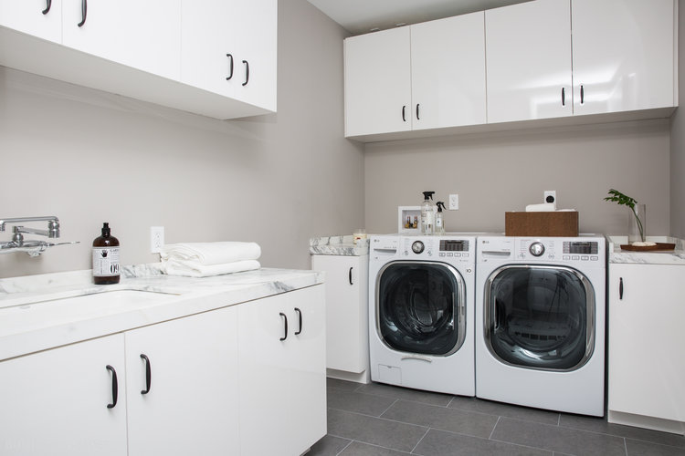Sarah Jacobs

"The coolest thing in here is the ability to have a 360-degree view. Where in New York can you look over the borough of Brooklyn and see the Atlantic Ocean, or go out and look to the east and see the planes land at LaGuardia Airport?" Eichner said.
Sarah Jacobs

Along with the incredible views, Eichner was also proud of the work put into the front door, which he noted is very much like one you might find at a home in Los Angeles.
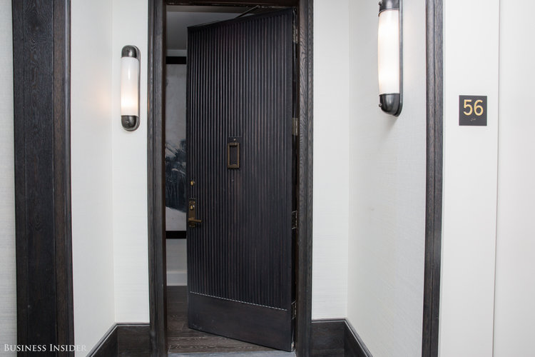Sarah Jacobs

